Connect the pictures with the correct words.
Poveži sličice s pravimi besedami.

 | ● |  | ● | Easter eggs
 | ● |  | ● | Easter basket
 | ● |  | ● | Bunny
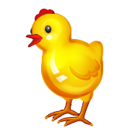 | ● |  | ● | Flowers
 | ● |  | ● | Chick
 | ● |  | ● | Easter hunt


Draw a picture for every word.
Nariši sličice za posamezne besede.

Chick | Flowers
Easter eggs | Bunny
Easter Basket

