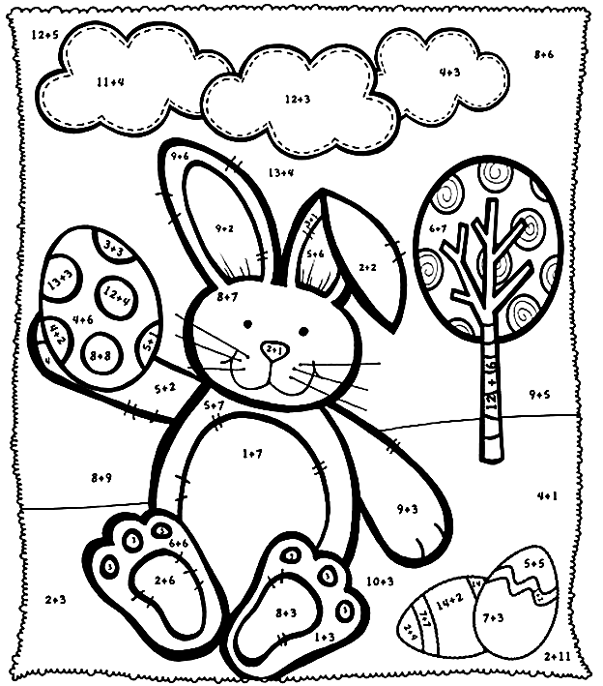

White = 4, 7, 12, 15 | Brown = 18
Green = 5, 13 | Blue = 14, 17
Pink = 3, 8, 11 | Purple = 10
Yellow = 6, 16

White = 4, 7, 12, 15 | Brown = 18
Green = 5, 13 | Blue = 14, 17
Pink = 3, 8, 11 | Purple = 10
Yellow = 6, 16

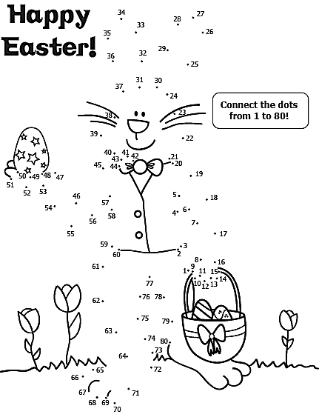
Poveži pike od 1 do 80!

