Let's repeat – PONOVIMO (rešitve)
- Odgovori na vprašanja zase.
Npr. Do you like marbles? Yes, I do.
- Do you like kites? Yes, I do. ALI No, I don't.
- Do you like puzzles? Yes, I do. ALI No, I don't.
- Do you like prams? Yes, I do. ALI No, I don't.
- Do you like skipping ropes? Yes, I do. ALI No, I don't.
- Do you like board games? Yes, I do. ALI No, I don't.
- Do you like watercolours? Yes, I do. ALI No, I don't.
- Do you like lollipops? Yes, I do. ALI No, I don't.
- Do you like crowns? Yes, I do. ALI No, I don't.
- Do you like biscuits? Yes, I do. ALI No, I don't.
- Do you like paper cups and straws? Yes, I do. ALI No, I don't.
- Preberi spodnje besedilo. Vstavi manjkajoče besede. Dve besedi sta odveč.

cake, Monday, toy, like, don't like, house, marbles, May
Hello,
My name is Mia. I like toys! My favourite TOY is my blue doll. I LIKE skipping ropes and balls, but I DON'T LIKE cars and trains. Cars and trains are for boys!
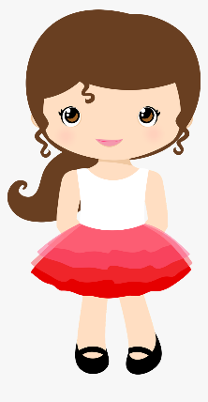
My brother's favourite toys are MARBLES. Marbles are small and fast. My birthday is in MAY. I invite my friends to a birthday party! We eat a birthday CAKE, biscuits and pizza!
What about you? Write to me.
Mia
Bi poskusil/-a odpisati Miji na pismo in povedati, katere so tvoje najljubše igrače, katerih ne maraš in kdaj imaš ti rojstni dan?
NPR.
Hello, my name is Eva. I like toys. My favourite toys are puzzles, prams and board games, but I don't like tractors and kites.
My birthday is in July. We sing, dance and eat a birthday cake. My friends give me presents.
Have a nice day.
Eva
- Poglej in napiši.
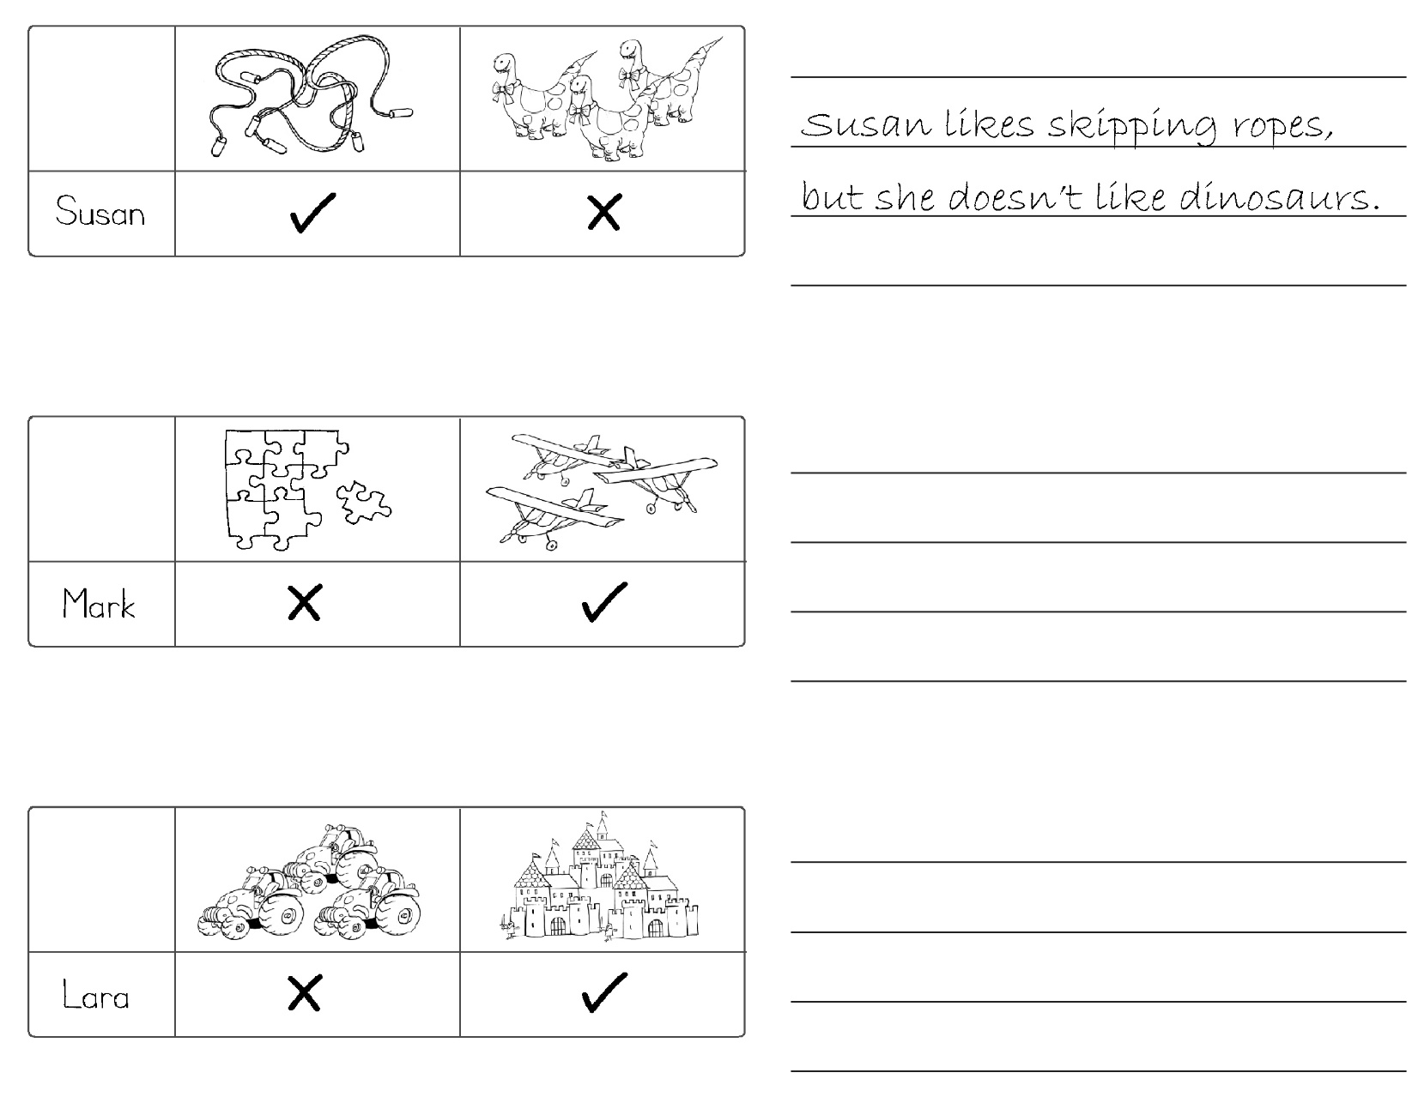

Mark likes toy planes (aeroplanes), but he doesn't like puzzles.

Lara likes castles, but she doesn't like tractors.

MY DICTIONARY_UNIT 4
IZDELAJ SI SLOVARČEK NOVIH BESED.
MOJ SLOVARČEK (ENOTA 4)
ENGLISH | SLOVENE
NALOGO SI REŠIL PRAVILNO, ČE SI IZBIRAL MED NOVIMI BESEDAMI IZ ENOTE 4
IN DA SI IZPOLNIL CELO TABELO.

