ZAPIŠI IN NARIŠI V ZVEZEK:
SHAPES

CIRCLE RECTANGLE

TRIANGLE SQUARE

HEART STAR

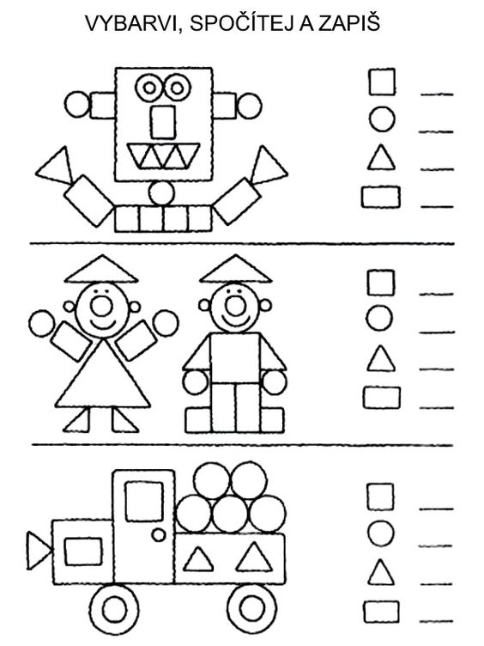
COUNT AND COLOUR. PREŠTEJ IN POBARVAJ.
CIRCLE - BROWN SQUARE - ORANGE
RECTANGLE – BLUE TRIANGLE - RED

