LET'S REPEAT  (PONOVIMO) | Ustno odgovori na vprašanja po angleško.  - What is your surname?  - How old are you?  - What is your favourite pet animal?  - What is your favourite farm animal?  - When is your birthday (month)?  - Do you like presents?  - Have you got in-line skates?  DANCE AND SING:  ALPHABET  https://www.youtube.com/watch?v=mrkIhHnKQTs  https://www.youtube.com/watch?v=FBQCgjo1QTU  MONTHS OF THE YEAR  https://www.youtube.com/watch?v=Cgr4joFfSFw
MY FAMILY  MOJA DRUŽINA | Today we will talk about family and family members. Danes se bomo pogovarjali o družini in družinskih članih.  What family members do you know?  - Mother (mommy), Father (daddy) … (naštej jih čim več)  Watch a video. Oglej si posnetek.  - STEVE AND MAGGIE: FAMILY  https://www.youtube.com/watch?v=VvrG4JguNQk  Odpri spletni evedež na strani 58 – Meet my family. Skušaj ustno odgovoriti na nalogo 1. a in nato poslušaj nalogo  1. b in si oglej slike. Poslušaj posnetek vsaj 2x.
MONDAY, 20. 4.
ZAPIS V ZVEZEK (20th Apr.)
Če za kakšno besedo nisi prepričan, kako se izgovori, jo vpiši v spletni PONS slovar in poslušaj - tako, kot smo delali tudi v šoli.
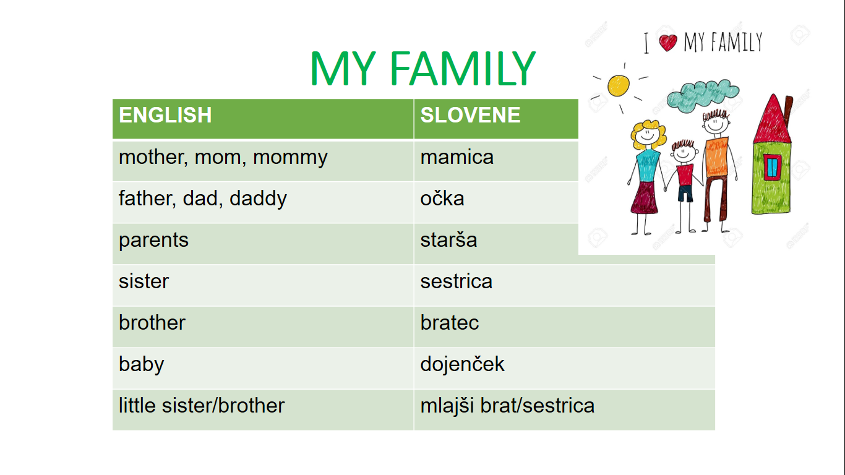

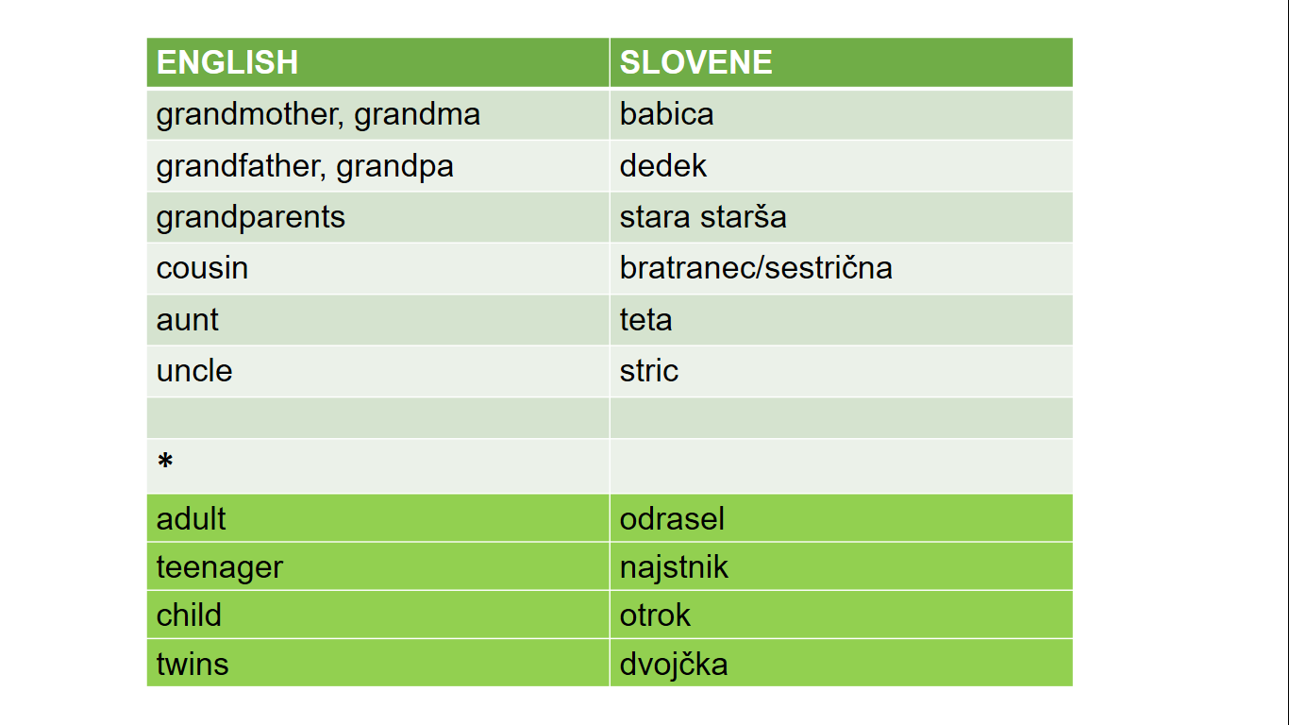

HOMEWORK: DANES JE NALOGA ČISTO PREPROSTA – ČIM VEČKRAT POIMENUJ ČLANE TVOJE DRUŽINE PO ANGLEŠKO, VELJA? Tudi tiste, ki trenutno niso s tabo …

