
In the boxes below you will find many adjectives you can use to describe the different animals.
Can you also come up with suggestions of your own for describing the many animals?

S I Z E
heavy, light, big, small, little, tiny, tall, short, fat, thin, skeletal, giant, underweight, wide
S H A P E
round, square, straight, triangular, oval, sleek, blobby, flat, elliptical, crooked, wavy
C O L O U R
pink, red, orange, black, yellowish, blue, dark, green, purple, white, gray, brown
S P E E D
quick, fast, slow, swift, speeding, rushing, hasty, bustling, rapid, snappy, brief, springy


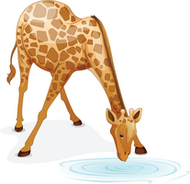
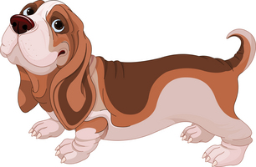



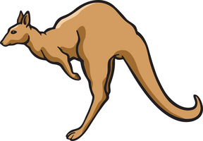
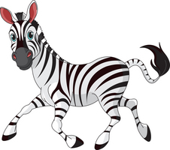
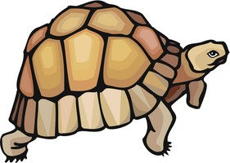

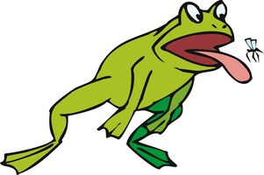
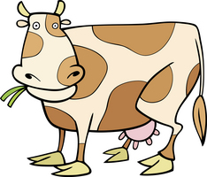
1

1. ____________________
2. ____________________
3. ____________________
4. ____________________
5. ____________________
2

1. ____________________
2. ____________________
3. ____________________
4. ____________________
5. ____________________
3

1. ____________________
2. ____________________
3. ____________________
4. ____________________
5. ____________________
4

1. ____________________
2. ____________________
3. ____________________
4. ____________________
5. ____________________
5

1. ____________________
2. ____________________
3. ____________________
4. ____________________
5. ____________________
6

1. ____________________
2. ____________________
3. ____________________
4. ____________________
5. ____________________
7

1. ____________________
2. ____________________
3. ____________________
4. ____________________
5. ____________________
8

1. ____________________
2. ____________________
3. ____________________
4. ____________________
5. ____________________
9

1. ____________________
2. ____________________
3. ____________________
4. ____________________
5. ____________________
12

1. ____________________
2. ____________________
3. ____________________
4. ____________________
5. ____________________
11

1. ____________________
2. ____________________
3. ____________________
4. ____________________
5. ____________________
10

1. ____________________
2. ____________________
3. ____________________
4. ____________________
5. ____________________

