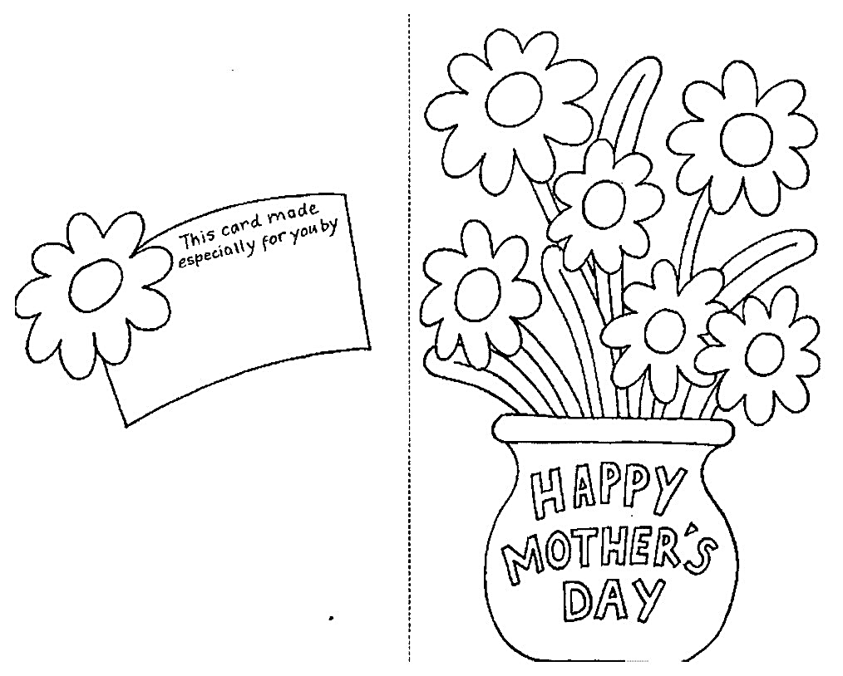

**FOR MY MOMMY** ________________ (NAME)

**FROM** __________________

(MY NAME)