HELLO MOMMY SONG
(MELODIJA MOJSTER JAKA)
WRITTEN BY TEACHER PETRA

HELLO, MOMMY
HELLO, MOMMY.
HOW ARE YOU?
HOW ARE YOU?
HAPPY MOTHER'S DAY!
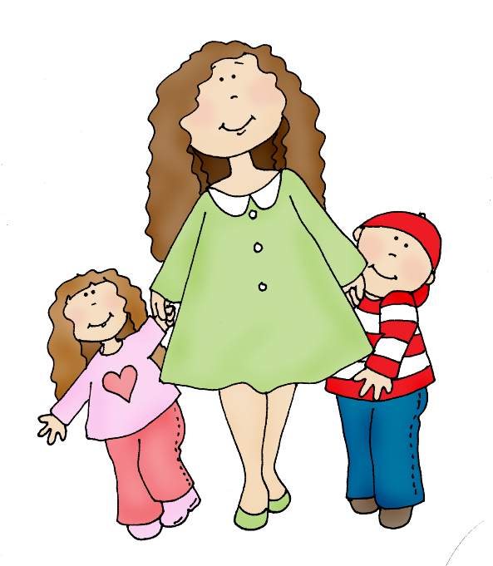
HAPPY MOTHER'S DAY!
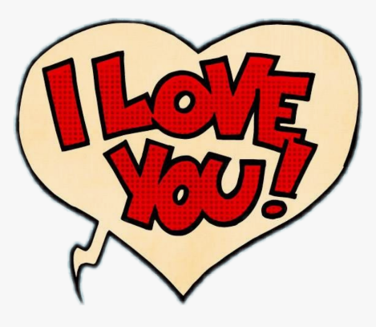
I LOVE YOU.
I LOVE YOU.

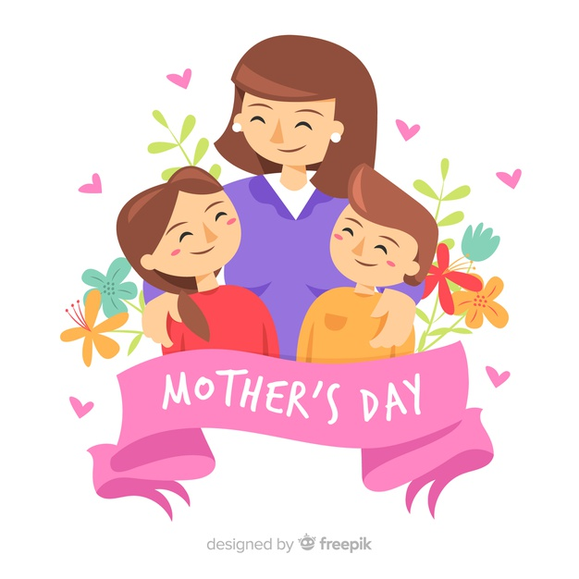

25th MARCH
MOMMY, HAPPY MOTHER'S DAY!

