MONDAY, 30. 3.
FUN TIME  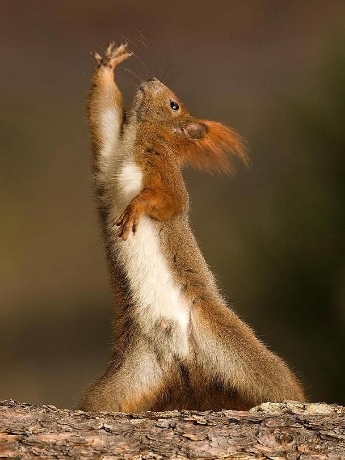 | DANCE AND MOVE:  - https://www.youtube.com/watch?v=xmz42aanXaM  - https://www.youtube.com/watch?v=OMg6t-z8KEI  - https://www.youtube.com/watch?v=7BUIfsKe4c0  - https://www.youtube.com/watch?v=Yj1TwQywaIE
LET'S PRACTISE
VADIMO

READ AND COMPLETE THE TEXT. Then copy the text in your notebook.
PREBERI IN DOPOLNI BESEDILO. Nato besedilo prepiši v svoj zvezek, ali nanj odgovori zase.

Hello,
my name is Eddie. I am _____________ 9 years old. I am a boy. My favourite day of the week is________________ D A F I Y R. I like ____________
and ______________________ weather .I don't like _______________
and_________________ weather. My favourite season of the year is

___________ AFLL .
My favourite month is _____________________ E P T E S M B E R .
What about you? What is your favourite day? What is your favourite month? What is your favourite season? Write to me.
Have a nice day.
Eddie

