Zdravo, učenjak/učenjakinja!
Veseli me, da se lotiš tudi teh nalog. Danes sem ti pripravila nekaj vaj besedišča in slovnice. V primeru, da nimaš tiskalnika, naloge rešuj v zvezek.

- Look and write.
Poglej in napiši.

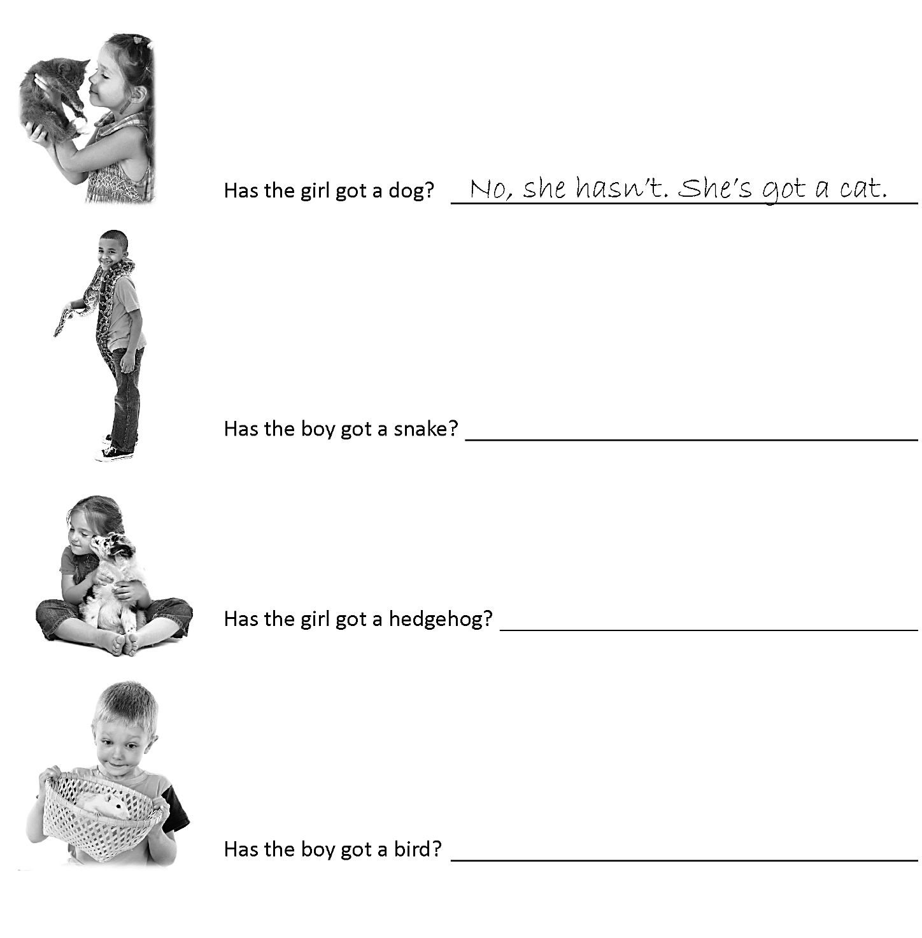

- Connect the picture to the sentence. Write a correct letter in a box.
Poveži sliko s stavkom tako, da vpišeš pravilno črko v okvirček.

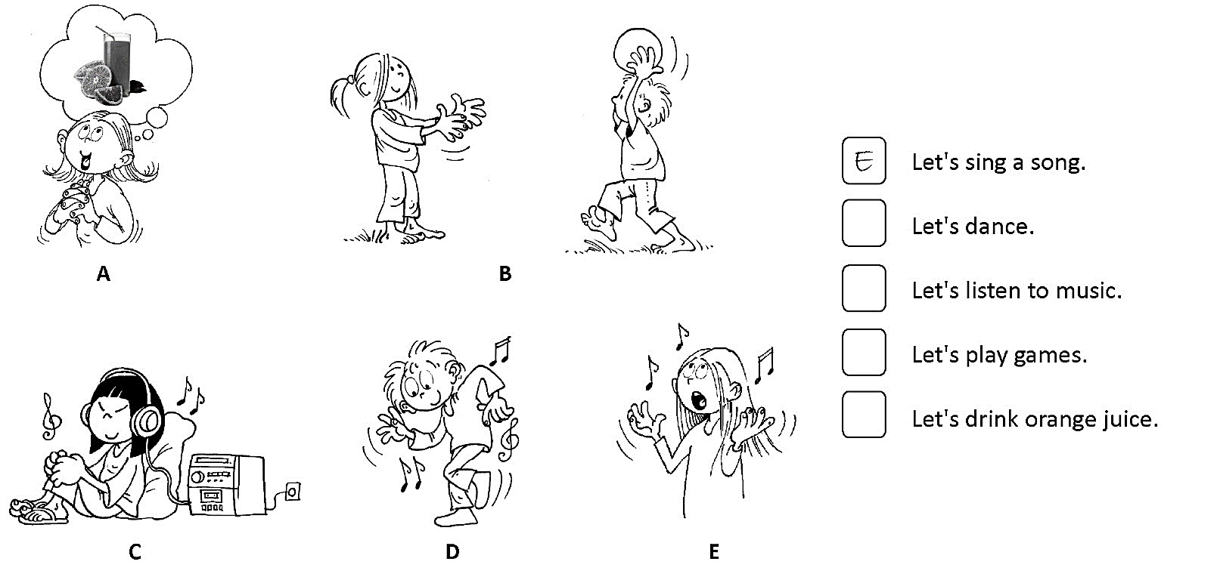
- Look, read and complete.
Poglej, preberi in dopolni.

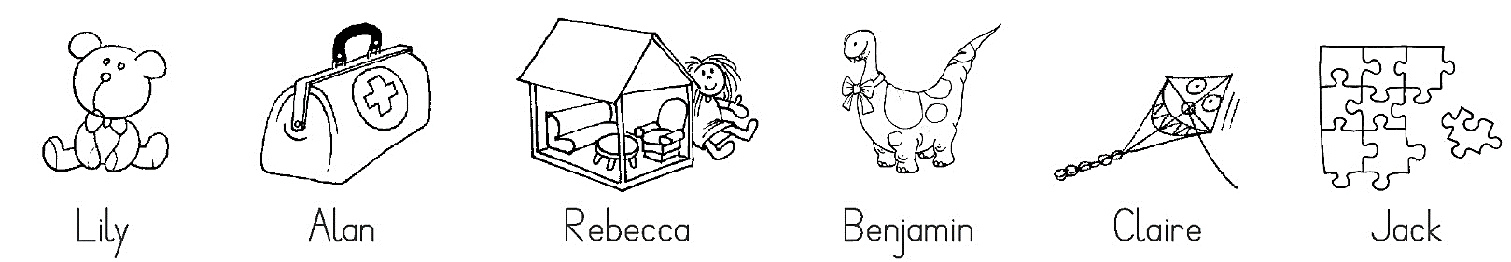
bear
What's Lily's favourite toy? It's the .
What's Benjamin's favourite toy? It's the .
What's Claire's favourite toy? It's the .

What's Alan's favourite toy? It's the .
What's Rebecca's favourite toy? It's the .
What's Jack's favourite toy? It's the .
- Look and complete. Use the words from the box. There are two words too many.
Poglej in dopolni. Uporabi besede v okvirčku. Dve besedi sta odveč.

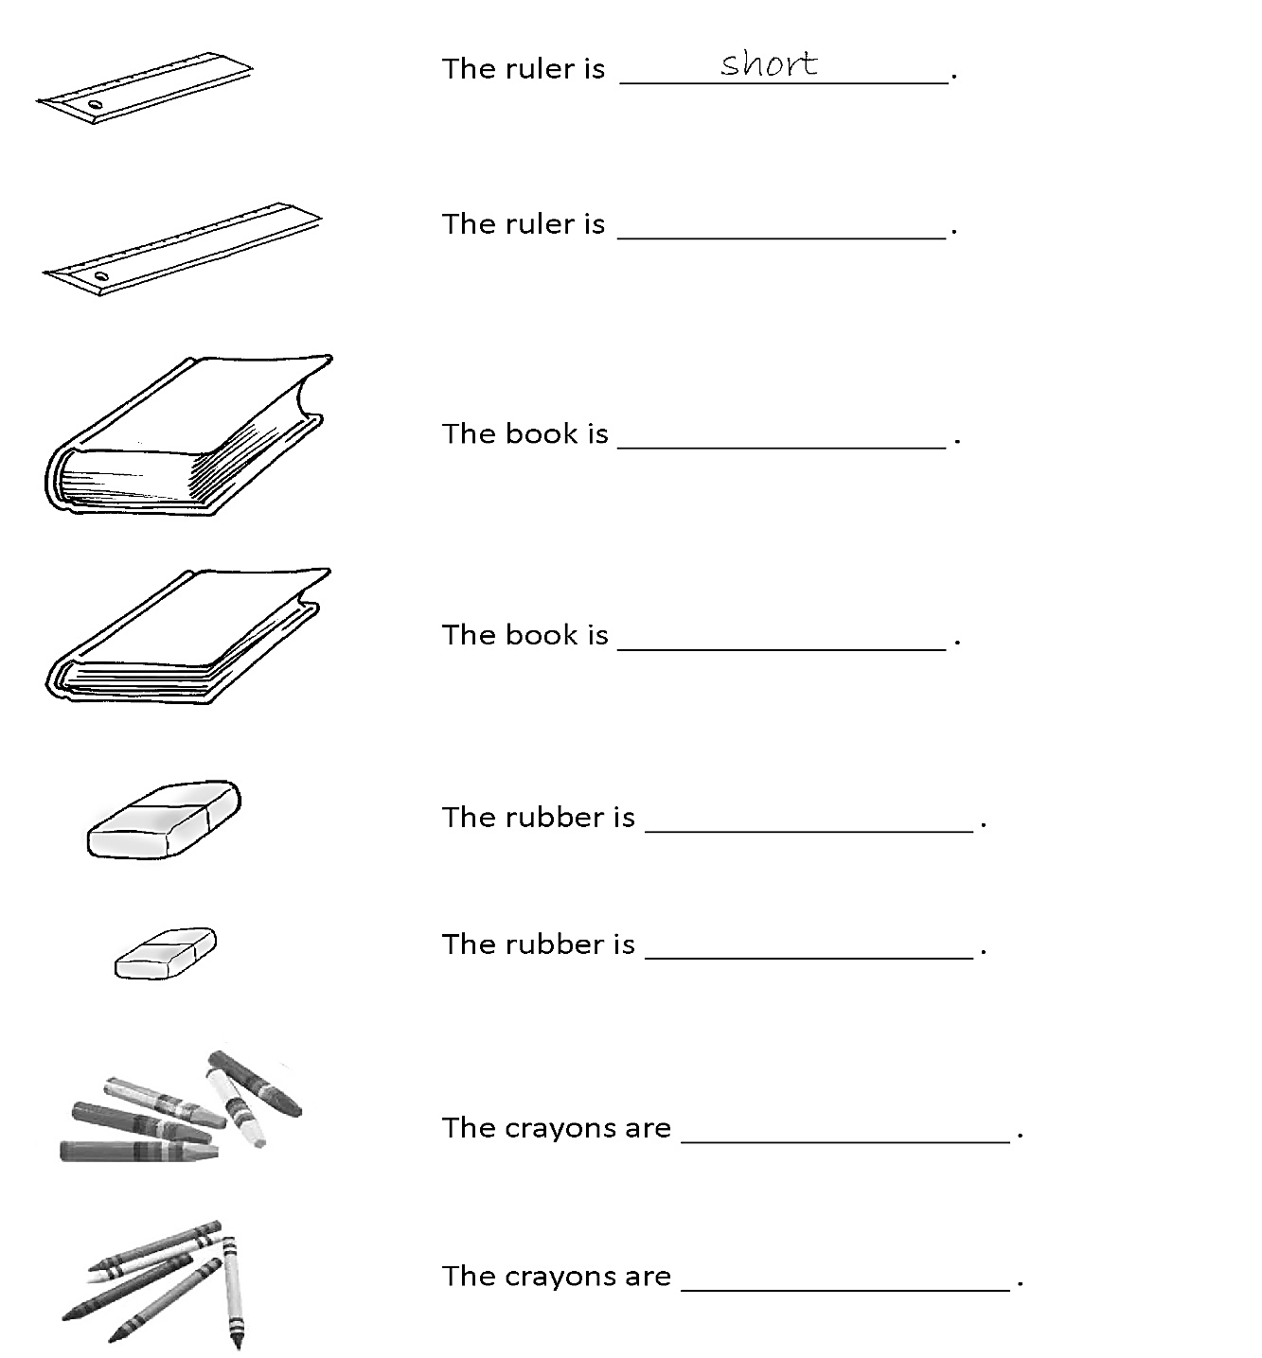
thick thin big fine long red short small thick thin

